Step 1: making the git repository by the enrollnment no.
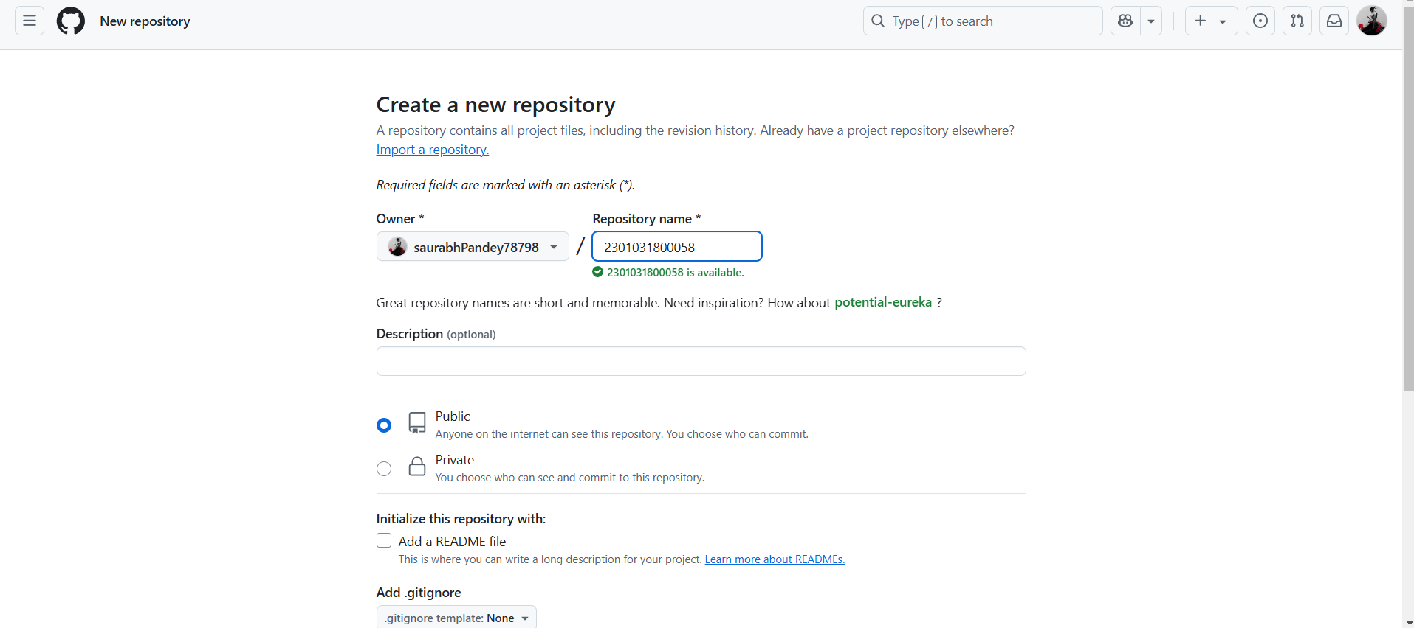

Step 2: making the folder name assignment 1.
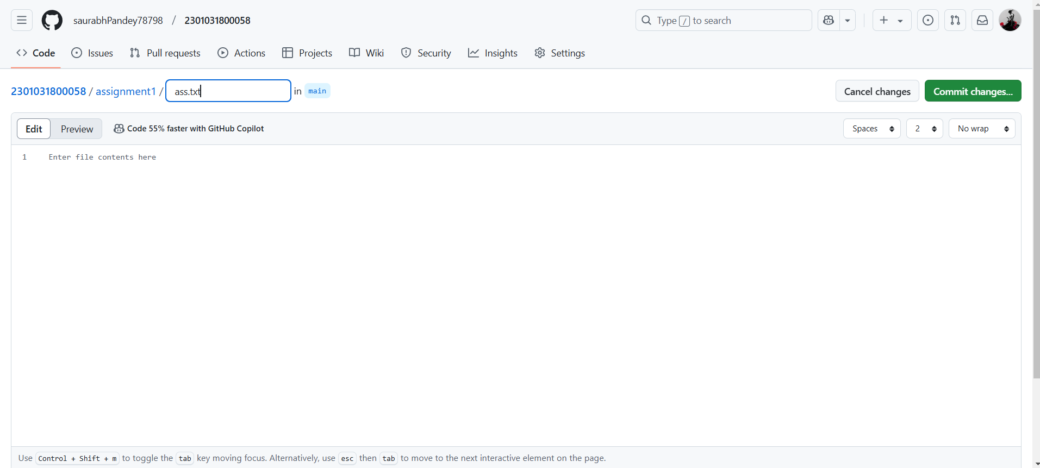

Step 3: making the folder name assignment 2.
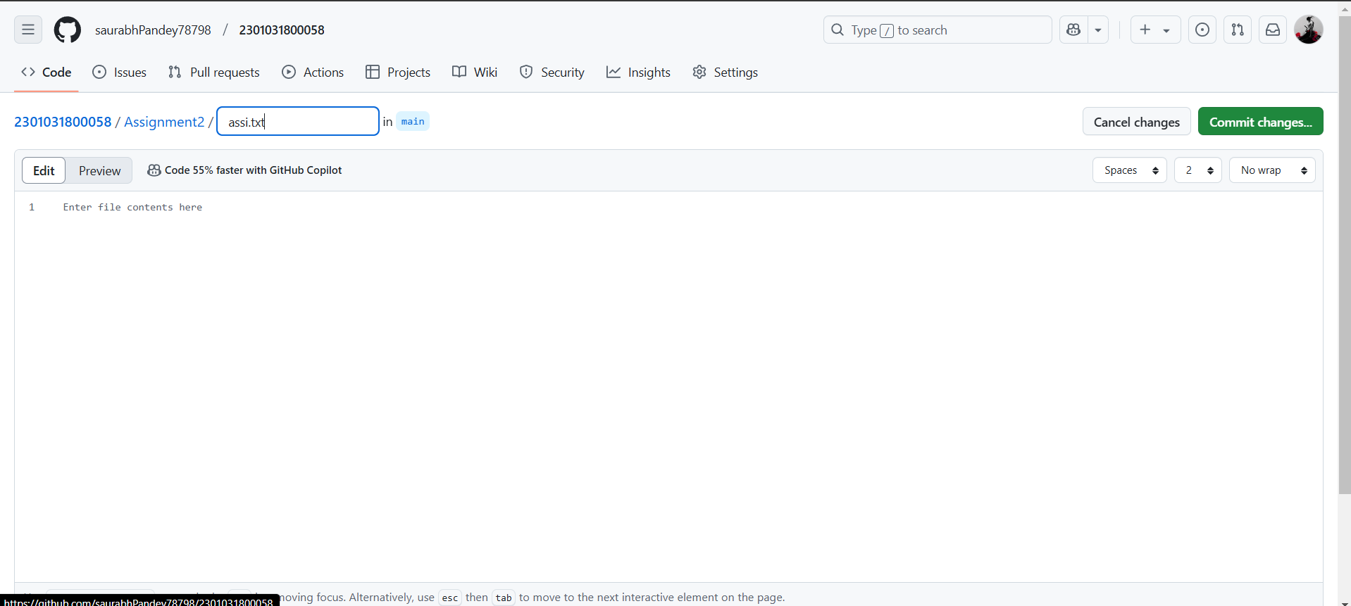

Step 4: now uploading the assignment according in the two folders.

